Q.1. Write a word count program using partitioner and implement the following logic in the partitioner words with length 5 should go into reducer 1 and words with length 6 should go into reduer 2 and the rest of the words should go into reducer 3.

CODE : -

Driver Class:-

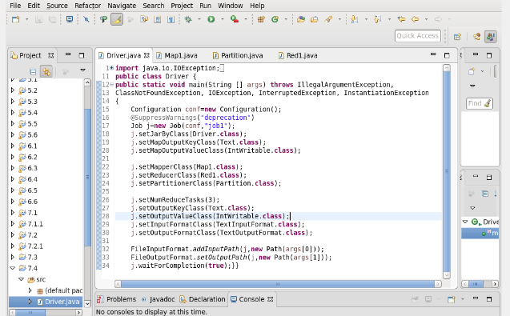

Mapper Class:-

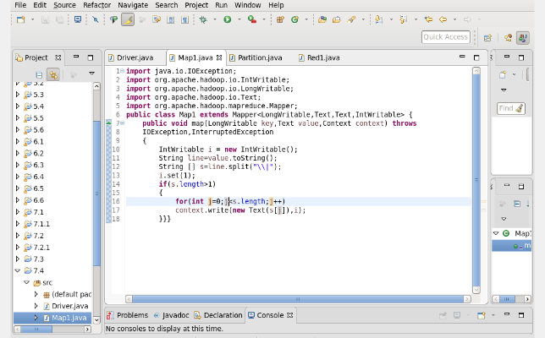

Partitioner Class:-

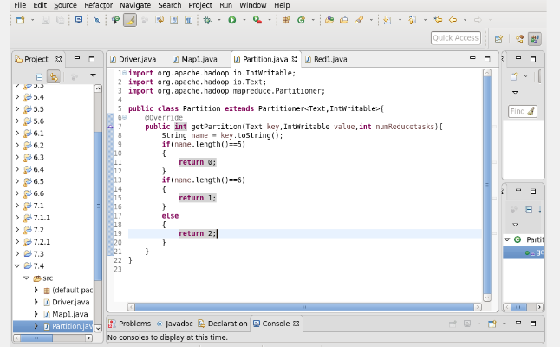

Reducer Class:-

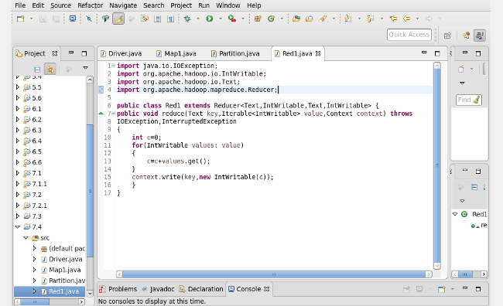

OUTPUT :-

